Grasscutters Lawncare
Lawn Maintenance Estimate for Happy Hotel
John Smith
7/11/2015

This document includes a basic estimate of lawn maintenance which includes, but is not limited to mowing, edging, blowing, hedge trimming, leaf clean up, as well as listed services below, etc.

Grass Cutters Lawncare

Your Address
Your Name
Your Phone #

Email: grasscutters@gmail.com

Grasscutters.com

Price Estimate Sheet for Customers Name

Regarding Property Lawn Maintenance for: Customers Address

Contents:

Page 1
Contents Page

Page 2
Lawn Care Maintenance Estimates

Page 3
Color Coded Map

Page 4
Reference Page
&
Liability Insurance Coverage

Regular Lawn Care Maintenance

This estimate includes the following:

Year Round (January-December) * Grasscutters Lawncare
- Weekly mowing all areas containing grass inside discussed areas during growing season (May -August)  - Bi Weekly mowing and leaf clean up in off season (September-April)  - Trimming (with weed eater) all applicable areas the mower could not reach (around buildings, trees, ditches etc)  - Edging all applicable curb, driveways & sidewalk  - Blowing and cleanup of all natural debris (grass, dirt, mulch) off all driveways, sidewalks, walkways & curbs after each lawn care maintenance  - Trimming of all bushes and hedges as needed monthly (Count-160 Small, 118 Medium, 11 Large), plus junipers trimmed and edged  - Annuel pruning back of all hedges (Count- 289)  - Annuel pruning back Crepe Myrtles (Count-13)  - Keeping all tree limbs trimmed away from building  - Basic trash pickup  - Parking Lot Weed Control  - Weed control in much bed areas  - Flower Install 2 times a year (front entrance of parking lot, building as well as two large planters at front entrance | Monthly  $625  Yearly  $7500 | Billed At the End of Each Month

Additional Services 1 Time Per Year (Optional)

Landscaping Options
*Color coded according to areas on the map on next page below. Choose 1 option from each area and add to get total job cost
Options | Area 1 (Blue) | Area 2 (Red) | Area 3 (Purple)
Option 1 | Mulch - $320 | Mulch - $1600 | Mulch - $940
Option 2 | Pine Needles $140 | Pine Needles- $900 | Pine Needles- $375
Option 3 | Rock-$810 (Per management request for safety codes)

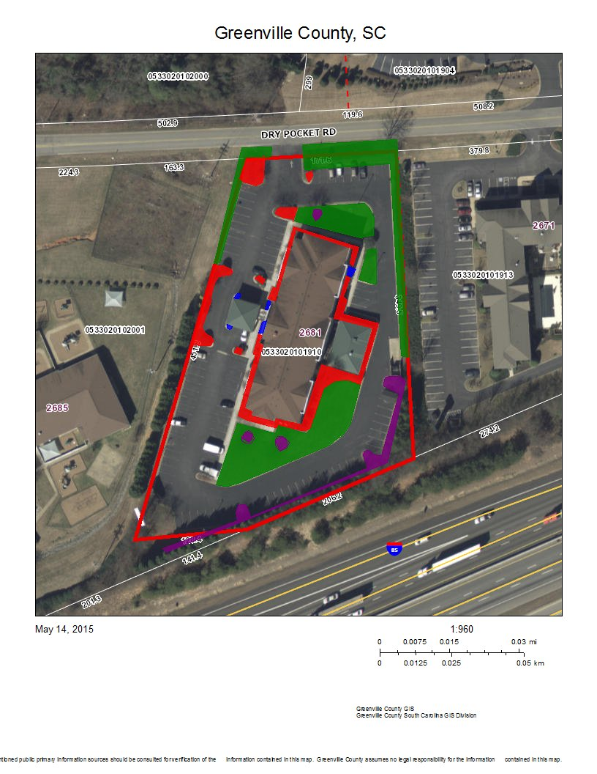
Reference Page

Some of Our Current Customers

Joe Smith- 303-325-4793 jsmith@gmail.com

David Pavelli – 303-351 9966 dpavelli@email.net

Bonnie Wilbur- bonniewilber1001@yahoo.com

John Brown (JB Thrift Stores)-864-282-6561 JB@jbthriftstore.org

{Tree Work Only } Bill Hammy (Electronics of America) – 434-971-7064

Jim Hammond (Pilgrim Properties) – 864-671-4904 jim@pilgrimpropertiesllc.com

Insurance Coverage

Cheap Insurance

1,000,000 Liability/ 2,000,000 Aggregate

Agent – Dudly Duragg (864-292-5408)

